**Energy Efficient Multipath Routing Protocol for Mobile ad-hoc Network Using the Fitness Function**

**ABSTRACT:**

Mobile Ad Hoc Network (MANET) is a collection of wireless mobile nodes that dynamically form a temporary network without the reliance on any infrastructure or central administration. Energy consumption is considered as one of the major limitations in MANET, as the mobile nodes do not possess permanent power supply and have to rely on batteries, thus reducing network lifetime as batteries get exhausted very quickly as nodes move and change their positions rapidly across MANET. The research proposed in this paper highlights this very specific problem of energy consumption in MANET by applying the Fitness Function technique to optimize the energy consumption in Ad Hoc On Demand Multipath Distance Vector (AOMDV) routing protocol. The proposed protocol is called Ad Hoc On Demand Multipath Distance Vector with the Fitness Function (FF-AOMDV). The fitness function is used to find the optimal path from the source to the destination to reduce the energy consumption in multipath routing. The performance of the proposed FF-AOMDV protocol was evaluated by using Network Simulator Version 2 (NS-2), where the performance was compared with AOMDV and Ad Hoc On Demand Multipath Routing with Life Maximization (AOMR-LM) protocols, the two most popular protocols proposed in this area. The comparison was evaluated based on energy consumption, throughput, packet delivery ratio, end-to-end delay, network lifetime and routing overhead ratio performance metrics, varying the node speed, packet size and simulation time. The results clearly demonstrate that the proposed FF-AOMDV outperformed AOMDV and AOMR-LM under majority of the network performance metrics and parameters.

**EXISTING SYSTEM:**

* Sun et al. proposed an Energy-entropy Multipath Routing optimization algorithm in MANET based on GA (EMRGA).
* The key idea of the protocol was to find the minimal node residual energy of each route in the process of selecting a path by descending node residual energy.
* It can balance individual nodes battery power utilization and hence prolong the entire networks lifetime and energy variance.

**DISADVANTAGES OF EXISTING SYSTEM:**

* Less Packet delivery ratio
* Low Throughput
* High End-to-end-delay
* More Energy consumption and Less Network lifetime.

**PROPOSED SYSTEM:**

* We proposed a new multipath routing protocol called the FF-AOMDV routing protocol, which is a combination of Fitness Function and the AOMDV’s protocol.
* In a normal scenario, when a RREQ is broadcasted by a source node, more than one route to the destination will be found and the data packets will be forwarded through these routes without knowing the routes’ quality.
* By implementing the proposed algorithm on the same scenario, the route selection will be totally different. When a RREQ is broadcast and received, the source node will have three (3) types of information in order to find the shortest and optimized route path with minimized energy consumption.

**ADVANTAGES OF PROPOSED SYSTEM:**

* High Packet delivery ratio,.
* Increase Throughput.
* Low End-to-end-delay
* Less Energy consumption and More Network lifetime.

**SYSTEM ARCHITECTURE**

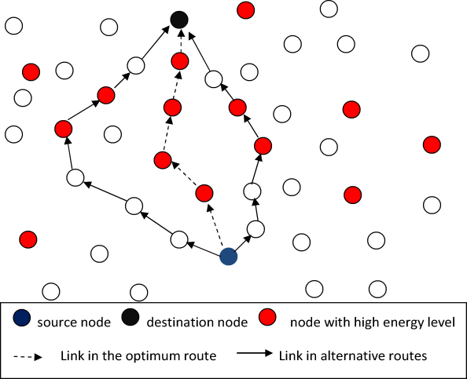

**MODULES:**

* Simulation Model
* Fitness Function
* FF-AOMDV

**MODULE DESCRIPTIONS:**

**Simulation Model:**

In this simulation model, we utilized the Constant Bit Rate (CBR) as a traffic source with 36 mobile nodes that are distributed randomly in a 1500 m* 1500 m network area; the network topology may therefore, undergo random change since the nodes’ distribution and its movement are random. The transmission range of the nodes was set to 250 m, while, for each node, the initial energy level was set to 100 joules. Three different scenarios were chosen to see how they are affecting the performance of the proposed FF-AOMDV protocol. In the first scenario, we varied the packet size as (64, 128, 256, 512, 1024) bytes and kept both the node speed and simulation time fixed as (2.5 meter/second and for 50 seconds) respectively. All other network parameters are the same for all runs and for all simulated protocols. In the second scenario, we varied the node speed as (0, 2.5, 5, 7.5, 10) seconds and kept the packet size and simulation time fixed as (256 bytes and 50 seconds) respectively. Finally, in the third scenario, we varied the simulation time as (10, 20, 30, 40, 50) seconds and kept the both the node speed and packet size fixed as (2.5 meters/second and 256 bytes) respectively.

**Fitness Function:**

The fitness function is an optimization technique that comes as a part of many optimization algorithms such as genetic algorithm, bee colony algorithm, firefly algorithm and particle swarm optimization algorithm. The fitness function finds the most important factor in the optimization process, which could be many factors depending on the aim of the research. In MANET, the fitness factor is usually energy, distance, delay, and bandwidth. This matches the reasons for designing any routing protocol, as they aim to enhance the network resources. In this research, the fitness function used is part of the Particle Swarm Optimization (PSO) algorithm. It was used with wireless sensor networks to optimize the alternative route in case the primary route fails. The factors that affect the choice of the optimum route are:

* The remaining energy functions for each node
* The distance functions of the links connecting the neighboring nodes
* Energy consumption of the nodes
* Communication delay of the nodes

**FF-AOMDV:**

In a normal scenario, when a RREQ is broadcasted by a source node, more than one route to the destination will be found and the data packets will be forwarded through these routes without knowing the routes’ quality. By implementing the proposed algorithm on the same scenario, the route selection will be totally different. When a RREQ is broadcast and received, the source node will have three (3) types of information in order to find the shortest and optimized route path with minimized energy consumption. This information includes:

* Information about network’s each node’s energy level
* The distance of every route
* The energy consumed in the process of route discovery.

The route, which consumes less energy, could possibly be (a) the route that has the shortest distance; (b) the route with the highest level of energy, or (c) both. The source node will then sends the data packets via the route with highest energy level, after which it will calculate its energy consumption. Alike to other multipath routing protocols, this protocol will also initiates new route discovery process when all routes to the destination are failed. In the event when the selected route fails, the source node will then selects an alternative route from its routing table, which represents the shortest route with minimum energy consumption. The optimal route with less distance to destination will consume less energy.

**SYSTEM REQUIREMENTS:**

**HARDWARE REQUIREMENTS:**

* System : Pentium Dual Core.
* Hard Disk : 120 GB.
* Monitor : 15’’ LED
* Input Devices : Keyboard, Mouse
* Ram : 1GB.

**SOFTWARE REQUIREMENTS:**

* Operating system : Windows XP/UBUNTU.
* Implementation : NS2
* NS2 Version : NS2.2.28
* Front End : OTCL (Object Oriented Tool Command Language)
* Tool : Cygwin (To simulate in Windows OS)

**REFERENCE:**

Mueen Uddin, Aqeel Taha, Raed Alsaqour, Tanzila Saba, “Energy Efficient Multipath Routing Protocol for Mobile ad-hoc Network Using the Fitness Function”, **IEEE Access, 2017.**